**CST-235 Topic 1 Activity 1**

Brydon K. Johnson

Grand Canyon University

CST-235

Mohamed Mneimneh

February 14, 2021

**PART 1**

Screenshot 1

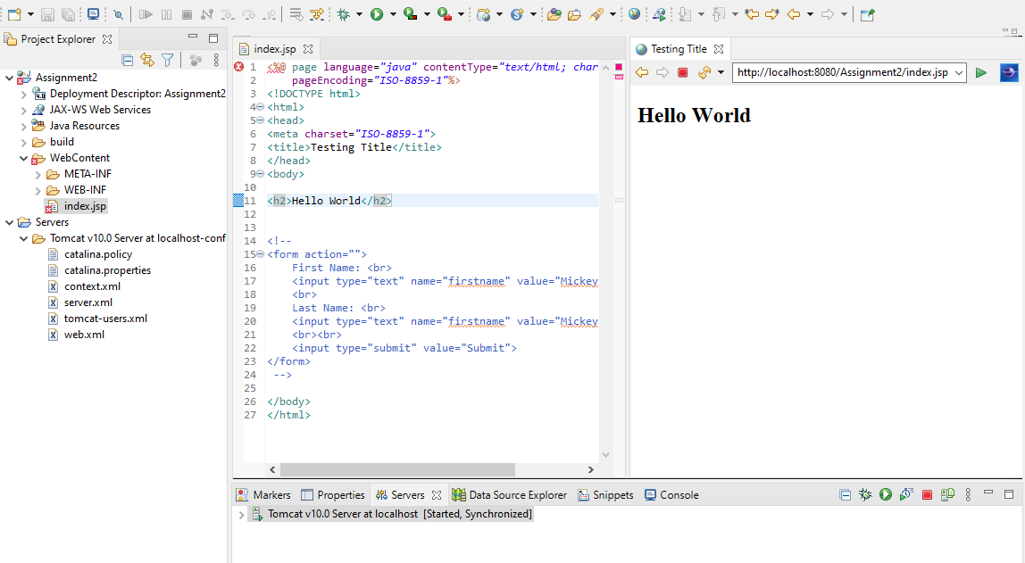

Screenshot 2

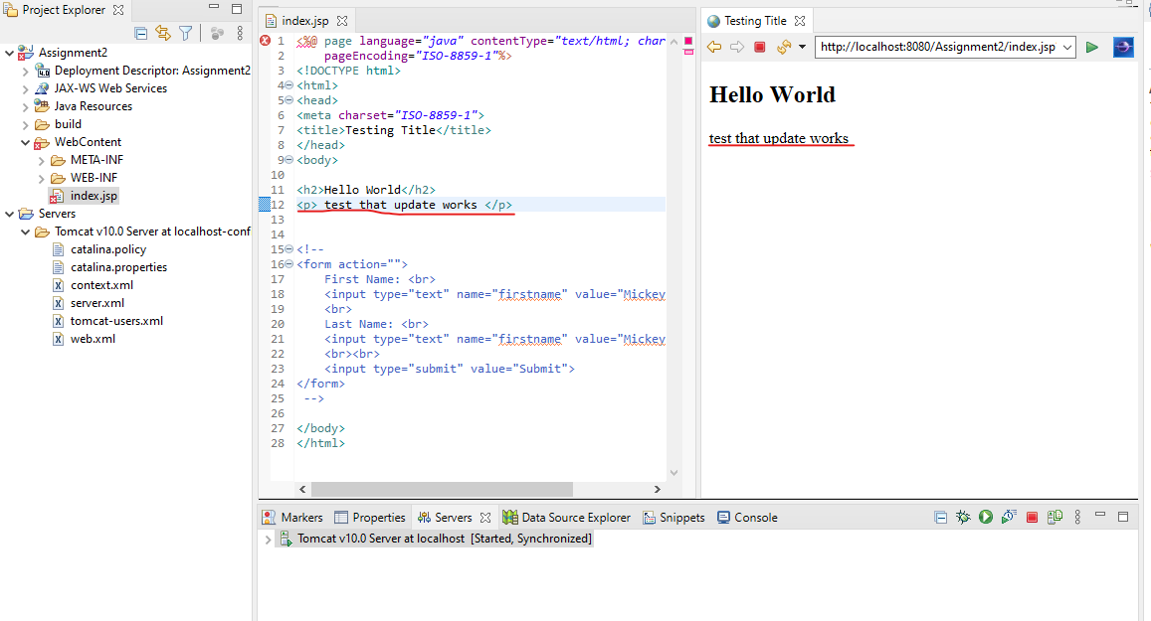

**PART 2**

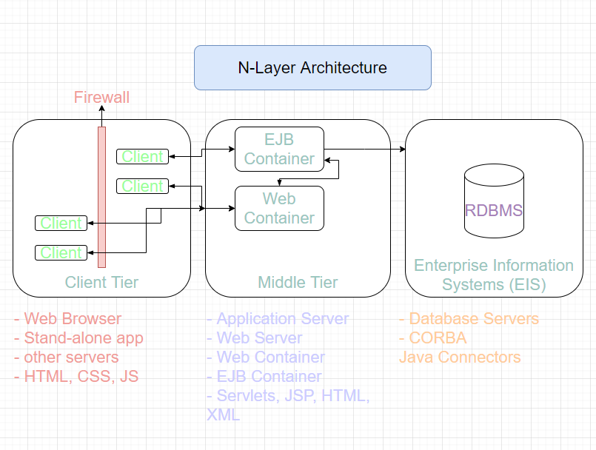

N-Layer Architecture refers to the structure of an application where different aspects of the application are separated by distinct layers. These layers are the Client Layer, the Middle Layer, and the EIS layer (Enterprise Information Systems). As developers, we tend to focus our time on the Middle Layer as this is where we bundle everything together, but the implementation of the client and EIS layers are equally as important. The Client layer is responsible for presenting data to the user as well as getting GET and POST requests to relay back to the database. This acts as the front end of an application. The Middle layer is responsible for interpreting the user actions and interacting with the database. The EIS tier is responsible for storing and providing data to the Middle Tier to be presented to the user.

A properly structured N-Layer application has the advantage of being easy to debug and improve on. When an application does not properly separate concerns, this can cause trouble as changes to one part of the application causes bugs in another. In order to supply an application with proper N-Layer architecture, it is important to avoid mixing the responsibilities of the different layers, and always ensure that each tier does not communicate with any other tier that is not either directly above or below it in the architecture model (or to the left or right depending on the depiction).